# Task:

**Task**

You have been tasked to construct an evidence guide of your learning. The subject of the evidence guide is defaulted to the construction of a podcast on cyber security for other students to consume (see below) -- however the subject matter and medium can be negotiated with the teacher for individual consideration.

The subject of the evidence (the learning material) can be collaborated on together in teams of 2 ± 1 but the evidence guide of your learning is individual.

An evidence guide is a centrally located document which contains evidence of your growing knowledge and understanding of the content taught in this course. By default you are required to submit the subject matter that you are using to base your evidence on and your evidence guide itself.

An evidence guide document is, generally, represented on a document that consists of short, and sharp, responses to high level questions. Historically, this document has been a PowerPoint document but this year the focus is on creating Markdown Documents.

**Topics for podcast** (choose one, all continuing content must be chosen before we can allow for duplicate choices).

1. Moonlight Maze
2. BlackEnergy/Arrakis02
3. Stuxnet
4. FancyBear
5. Industroyer/Crash Override
6. The Shadow Brokers
7. EternalBlue
8. Mimikatz
9. NotPetya and its impact on Ukraine
10. NotPetya and its impact on Maersk

**Each must podcast include the following at a minimum**

* An introduction to the topic
* A summary of what the topic is about including placing it in the historic timeline
* Information regarding the topic on technology or industry

Additionally, the group must submit an annotated bibliography of their work.

* An annotated Bibliography that represents your research. This should have multiple resources. There is no hard minimum limit but you should have multiple supporting pieces of evidence.
* A script where major claims are linked to the bibliography
* An audio or video podcast piece that goes for no less than 5 minutes and no more than 10 minutes

**Evidence Guide**

Individually, Students must respond to the following questions:

* Question 1: What was the process you used to ensure that you would meet all of the required elements of the Podcast? What were the elements, how did you know this?
* Question 2: How did your existing knowledge and/or understanding of this topic within Information Technology help inform your work on this work?
* Question 3: How has your understanding of this topic within Information Technology changed over the course of this assignment?

Details about how to answer these questions can be found in the rubric.

##### Section 1: Knowledge Comprehension, and Application

This section of the rubric consists of the required elements of the assignment. Students should take special care to include ALL these elements as they are often extended in the following sections

##### Section 2: Analysis, Synthesis, and Evaluation.

This section will evaluate your ability to include critical thinking and justification elements into your work. Often the requirements for extension are not explicitly given, so it will be up to the you to decide how best to demonstrate what you have learned beyond the required unit goals and curriculum. Items such as 3D models, pictures, drawings, diagrammatic responses, notes, evidence of problem solving, advanced programming concepts, elegant responses, media, etc., are all available options.

##### Section 3: Submission Guidelines

For this section, students will be expected to provide a submission which fulfills all of the formatting and citation requirements listed in this assessment sheet but also that the submission is of a professional quality. Be aware, points in this section could be 2- or 4-point items. Treat them accordingly.

## Submission

All submission items should be stored in an appropriate format. For example, code must be stored in a programmatical format so it can be evaluated (**images of code, or code simply copied and pasted into a document, will not be marked**)

Evidence of working material must be recorded where appropriate. For example, if you are showing how your game meets some requirement, you must submit a recording. Similarly, if you are showing how your robot meets a requirement, you must record it.

If you are unsure if an element needs to be recorded, **ask the teacher.**

**All materials must be submitted to google classrooms.**

Students are responsible for keeping backups/master-copies.

## SCORING NOTES

Formatting for all typed/written assessments should be as follows:

|  |  |  |  |  |  |  |
| --- | --- | --- | --- | --- | --- | --- |
| Google Doc | 11-12 Pt | 1.15-1.5 Line Spacing | 1 Space between paragraphs | Spelling and Grammar “Soft Limit” | In-Text Citations with footnotes | Title Page/Slide:   * Name * Date * Class * Aim * Assessment title |
| Slides | 10-12 pt. font text  14-24 pt. font titles | 1.0 1.15 Line Spacing | Bullet Points Preferred | Word Count per slide >100-110 “Soft Limit” | Approved Templates and Themes |
| Code |  |  |  |  |  |  |
| Markdown |  |  |  |  |  |  |

*“Soft Limits” are not rigidly defined limits and will be assessed on a case-by-case basis. Ask for clarification for specific tasks*

## Possible Scoring Groups are out of 2 or 4 Points.

**2-Point Criteria - Knowledge and Understanding**

*Criteria assessed as 2-Points are classified as Knowledge and Understanding criteria. These will examine and evaluate a student’s ability to state facts and define terms and concepts effectively. Analysis and synthesis of the information will not be assessed through these criteria.*

|  |  |  |  |
| --- | --- | --- | --- |
|  | **0 Points** | **1 Point** | **2 Points** |
| **2 Point Criteria** | Not present or able to be assessed as the required criteria | Item is presented and **does meet** expectations for quality, rigour, or detail | Item is presented and **does** meet expectations for quality, rigour, or detail |

**4-Point Criteria - Analysis and Synthesis and Expert Review**

*To show true mastery of your developing skills, students must show that they can go beyond simple repetition of the given tasks or an explanation of processes. Students will show their ability to show higher order thinking through analysis, evaluation, or the linking of multiple fields of learning to solve problems in novel ways.*

**Analysis and Synthesis**

*Analysis and Synthesis components evaluate a student’s ability to effectively review data and understandings and develop these into a coherent and relevant statement. Analysis refers to the generating of thoughts from interpreting the data, while synthesis refers to combining analysis of the data with other relevant information to develop an original and effective idea.*

|  |  |  |  |  |  |
| --- | --- | --- | --- | --- | --- |
|  | **0 Points** | **1 Point** | **2 Points** | **3 Points** | **4 Points** |
| **4 Point Criteria** | Not present or able to be assessed as the required criteria | Item is **presented and explained**. However, it **does not show any evidence of higher order thinking** such as analysis, evaluation, or synthesis. | Item is presented and **shows appropriate evidence of higher order thinking** such as analysis, evaluation, or synthesis. | Item is presented and **exceeds** **expectations** for **evidence of higher order thinking** such as analysis, evaluation, or synthesis.  **-or-**  Item is presented and **shows appropriate evidence of higher order thinking** such as analysis, evaluation, or synthesis and **exceeds expectations** for quality, rigour, or understanding of the selected mastery. | Item is presented and **exceeds** **expectations** for **evidence of higher order thinking** such as analysis, evaluation, or synthesis. Additionally, this item **exceeds expectations** for quality, rigour, or understanding of the selected mastery. |

**Expert Review**

*Expert Reviews evaluate a student’s ability to build solutions using the skills that have been taught during the semester. Criteria assessed as 4-Points are classified as Analysis and Synthesis criteria. These will examine and evaluate a student’s ability to effectively review data and understandings and develop these into a coherent and relevant statement. Analysis refers to the generating of thoughts from interpreting the data, while synthesis refers to combining analysis of the data with other relevant information to develop an original and effective idea.*

|  |  |  |  |  |  |
| --- | --- | --- | --- | --- | --- |
|  | **0 Points** | **1 Point** | **2 Points** | **3 Points** | **4 Points** |
| **4 Point Criteria** | Not present or able to be assessed as the required criteria | Item is **presented** and broadly **solves the problem**. However, upon review, it **does not** show any evidence of appropriate mastery. | Item is **presented** and broadly **solves the problem**. On review, it **does** show any evidence of appropriate mastery. | Item is **presented and solves the specific problem**. On review, the evidence shows understanding **beyond expected mastery**.  -or-  Item is **presented** and broadly **solves the problem**. On review, it **does** show any evidence of appropriate mastery and is done so in a **well-constructed** or design method that **clearly shows higher levels of understanding**. | Item is **presented and solves the specific problem**. On review, the evidence shows understanding **well** **beyond expected mastery** and is done so in a **well-constructed** or design method that **clearly shows higher levels of understanding**.. |

**Multiplier**

Criteria will be combined with a **Multiplier**. While each criterion will be scored on the 0-1-2-4 scale, the multiplier will attach relevant worth to each criterion. Be aware of these multipliers and dedicate appropriate time to ensure you achieve your best result.

**Achievement Standards:**

**Evidence of higher order learning:**

What is it that I mean by “higher order thinking”?

It means I want you to go beyond just replicating what we do in class. I want you to dig into your brain and understand why you did something, what about it was great, what could be improved.

Why is this important? Reflective thinkers are able to go beyond what they are taught and can customise their learning to ben

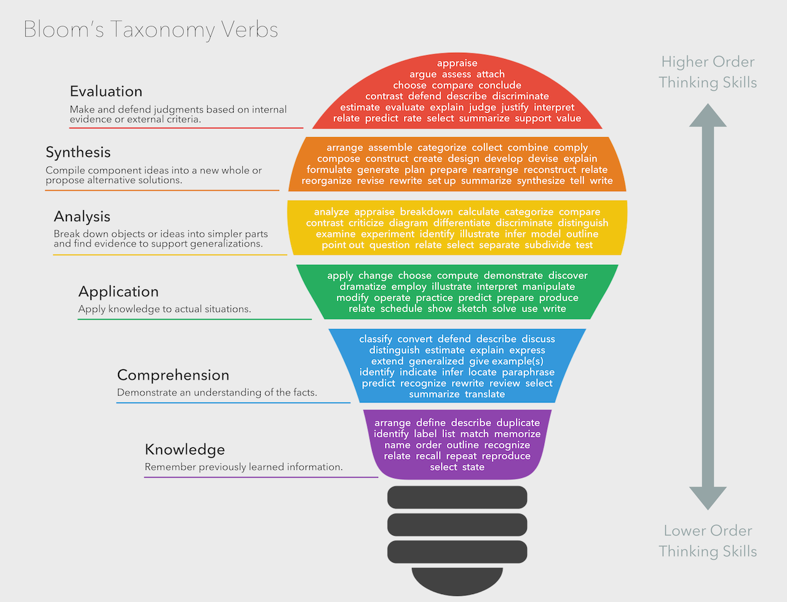

## Rubric

|  |  |  |  |  |  |  |
| --- | --- | --- | --- | --- | --- | --- |
|  | **Knowledge, Comprehension & Application** |  |  |  |  |  |
| **CRITERIA** | **EXPECTATIONS** | **POSS** | **STUDENT** | **GIVEN** | **MULTI** | **TOTAL** |
| **Podcast**  (group) | You have submitted evidence of completing required assessment material. This evidence is submitted in an appropriate format unless negotiated for a different format.  There is evidence of the following submissions:   * An introduction to the topic * An inclusion that situates where in the timeline of the first cyber war your topic is in (or relative timeline if negotiated a separate topic) * Detailed information on the selected topic   Evidence for knowledge, comprehension, and application may include:   * **Knowledge**: Your evidence highlights that you recall, and list relevant terms covered in your learning. It may tell a story to the reader (the teacher) or state the conditions of your learning. * **Comprehension**: Your evidence highlights that you can identify key aspects of your learning or explains to the author what you've done. * **Application**: It is clear from your evidence that you constructed a complete submission | 2  2  2  2 | __/2 __/2 __/2 __/2 | __/2 __/2 __/2 __/2 | A x2  T x 1 | A __/8 T __/4 |
| **Evidence Guide**  (individual) | You have submitted evidence of your evidence guide. By default, your evidence guide responses to each of the three questions selected by your teacher. However, these questions can be negotiated or reframed with your teacher.   To achieve a passing grade (2) you must submit a serious attempt to response to the question. By default, your submission for the evidence guide would be on a Google Slide or PowerPoint document. This document has a maximum space allotment of 3 slides per question.   Additional space can be used for introduction, indexes, and summary slides. The output can be negotiated with the teacher. Previous submissions have allowed for Google Sites, HTML, or Markdown documents.  Evidence for knowledge, comprehension, and application may include:   * **Knowledge**: Your evidence highlights that you recall and list relevant terms covered in your learning. It may tell a story to the reader (the teacher) or state the conditions of your learning. * **Comprehension**: Your evidence highlights that you can identify key aspects of your learning or explains to the author what you've done. * **Application**: It is clear from your evidence that you constructed a complete submission | 2  2  2 | __/2 __/2 __/2 | __/2 __/2 __/2 | - | __/6 |
|  | **Analysis, Synthesis & Evaluation** |  | | **SUB TOTAL** | | **A _ / 30**  **T _ / 20** |
| **Question 1** | **Question**: What was the process you used to ensure that you would meet all the required elements for the tutorial?  Evidence guides are a tool **you use to highlight your learning to the teacher**. Learning how to reflect on your learning during your assessments and identifying what parts of your work were high quality and what you could do to improve your work is an essential aspect of education.  You will present your **evidence guide within a PowerPoint document**. Your response can be **no more than 3 slides** **following the style guide** for PowerPoint documents.  This aspect of the assessment evaluates your ability to **analyse your learning**, identify **how and when you synthesised new understanding** on your own, and your ability to **assess your work**  Each of your questions will be marked against the following aspects of your ability to:   * express **your understanding of technology** concepts and principles * **your ability to communicate ideas** appropriately in the selected medium   Evidence for higher order learning may include:   * **Analysis**: Your evidence shows a reasoned understanding of what you did and why you did it. For example, you may have explained how you did X, Y, and Z, but you continue to explain why you did them the way you did. * **Evaluative**: your evidence makes a judgement of something or between multiple things. This judgement may be the value of one thing over another or a highlighting the major differences between two things. * **Transferal**: your evidence highlights when you apply information, strategies, or skills that you have learnt to a new situation or context. | 4  4 | __/4 __/4 | __/4 __/4 | A x1  T x 2 | A __/ 8  T __/16 |
| **Question 2** | **Question**: How did your existing knowledge and/or understanding of Information Technology helped inform your work on the tutorial.  Evidence guides are a tool **you use to highlight your learning to the teacher**. Learning how to reflect on your learning during your assessments and identifying what parts of your work were high quality and what you could do to improve your work is an essential aspect of education.  You will present your **evidence guide within a PowerPoint document**. Your response can be **no more than 3 slides** **following the style guide** for PowerPoint documents.  This aspect of the assessment evaluates your ability to **analyse your learning**, identify **how and when you synthesised new understanding** on your own, and your ability to **assess your work**  Each of your questions will be marked against the following aspects of your ability to:   * express **your understanding of technology** concepts and principles * **your ability to communicate ideas** appropriately in the selected medium   Evidence for higher order learning may include:   * **Analysis**: Your evidence shows a reasoned understanding of what you did and why you did it. For example, you may have explained how you did X, Y, and Z, but you continue to explain why you did them the way you did. * **Evaluative**: your evidence makes a judgement of something or between multiple things. This judgement may be the value of one thing over another or a highlighting the major differences between two things. * **Transferal**: your evidence highlights when you apply information, strategies, or skills that you have learnt to a new situation or context. | 4  4 | __/4 __/4 | __/4 __/4 | A x1  T x 2 | A __/ 8  T __/16 |
| **Question 3** | **Question**: How has your understanding of Information Technology changed from the start of this assignment time until now?  Evidence guides are a tool **you use to highlight your learning to the teacher**. Learning how to reflect on your learning during your assessments and identifying what parts of your work were high quality and what you could do to improve your work is an essential aspect of education.  You will present your **evidence guide within a PowerPoint document**. Your response can be **no more than 3 slides** **following the style guide** for PowerPoint documents.  This aspect of the assessment evaluates your ability to **analyse your learning**, identify **how and when you synthesised new understanding** on your own, and your ability to **assess your work**  Each of your questions will be marked against the following aspects of your ability to:   * express **your understanding of technology** concepts and principles * **your ability to communicate ideas** appropriately in the selected medium   Evidence for higher order learning may include:   * **Analysis**: Your evidence shows a reasoned understanding of what you did and why you did it. For example, you may have explained how you did X, Y, and Z, but you continue to explain why you did them the way you did. * **Evaluative**: your evidence makes a judgement of something or between multiple things. This judgement may be the value of one thing over another or a highlighting the major differences between two things. * **Transferal**: your evidence highlights when you apply information, strategies, or skills that you have learnt to a new situation or context. | 4  4 | __/4 __/4 | __/4 __/4 | A x1  T x 2 | A __/ 8  T __/16 |
|  | **Submission Guidelines** |  | | **SUB TOTAL** | | **A __/24**  **T __/48** |
| **Readability** | **Assessment submission is ordered** and has a definite pattern to its construction. **The reader is not confused as to the content in any given section** and can follow the flow of the submission easily. | 4 | __/4 | __/4 | X2 | __ / 8 |
| **Formatting** | **Students have** **followed the formatting instructions** including any provided templates and guides **or have created their own**, legible formatting guide **and applied it constantly**. | 2 | __/2 | __/2 | - | __ / 2 |
|  |  |  | | **SUB TOTAL** | | **__ /10** |
|  | DAYS LATE ___/7 = ___% |  |  | **FINAL** | | **A __/64 T __/78** |

## VET Competencies

|  |  |  |  |
| --- | --- | --- | --- |
| **Result** | **Vocational competencies assessed via this task** | | **Aspect of task addressing competency** |
|  | BSBOHS201A | Participate in OHS processes | Proper use of equipment & evacuation drills |
|  | ICAICT202A | Work and communicate effectively in an IT environment | Researching, creating, printing & submitting of Research Report |
|  | ICAICT201A | Use Computer Operating System and Hardware | Participation in organised IT activity & researching & creating report |